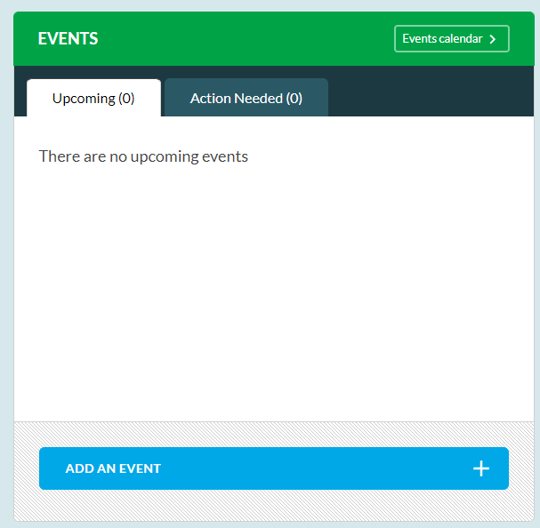
wher
Step one:
Click on the events Calendar

Step two:
Click where is says our events

Step three:
Select Inter School Events
Select All events in our area

Step Four:
Change the drop down to Primary/Secondary
The events calendar should now open and you can select and enter the events

Step five:
Wait to be accepted by the SGO team


